Contents
Enable User Management 2
Add a New User 3
Add a User to Multiple Shops in PPG LINQ Color 6
Log In to Another Shop in PPG LINQ Color 6
Forgot PIN 7
Main account (uses an email address to login into PPG LINQ Color) 7
PIN-enabled user (uses a PIN to log in to PPG LINQ Color) 8
Remove a User 8
Restore a Removed User 8
User Icons 10

Enable User Management
- Log in to PPG LINQ as the primary contact for the Bodyshop.
- On the Home screen, click the Settings tile.
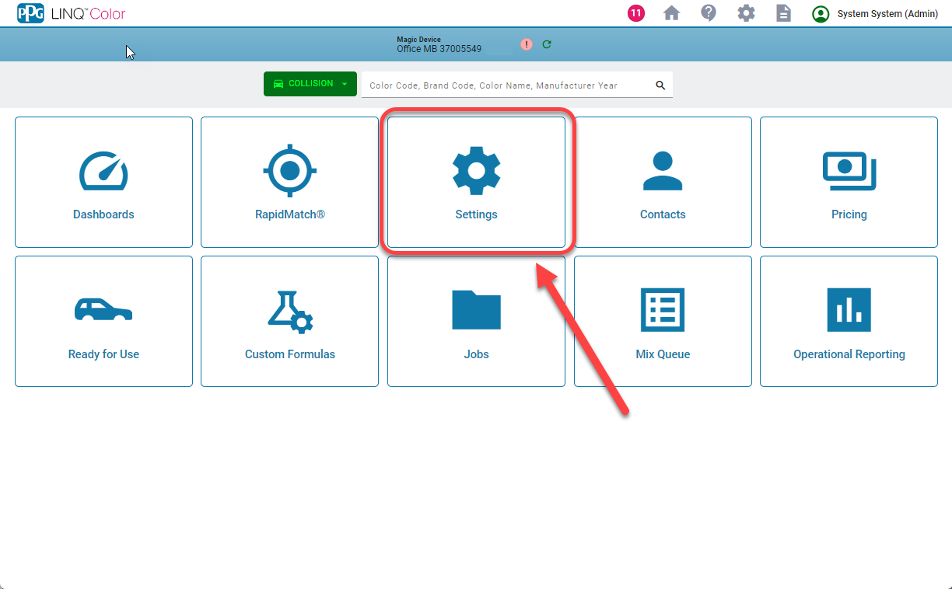
- On the Settings screen, click the Configuration tile.
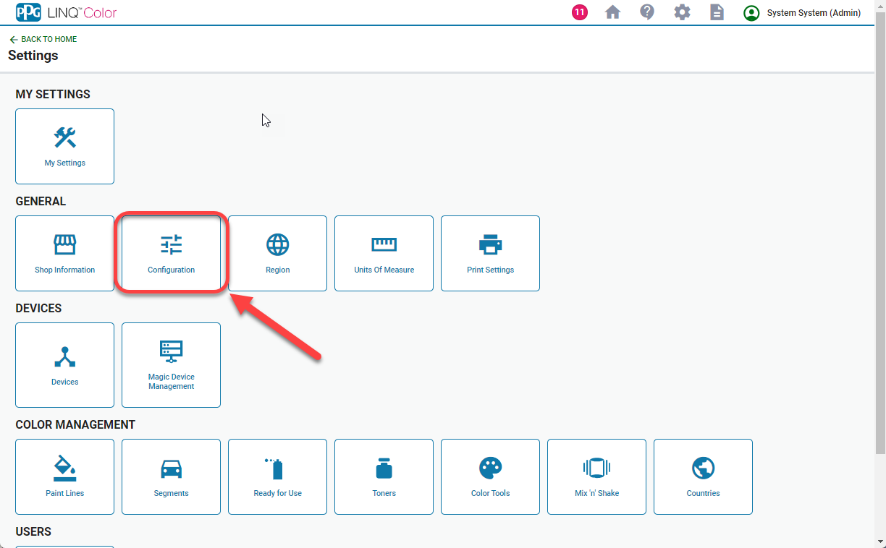

- On the Application Settings screen with the General category highlighted, ensure ‘User Management’ has a checkmark (even if it is gray) and save changes.
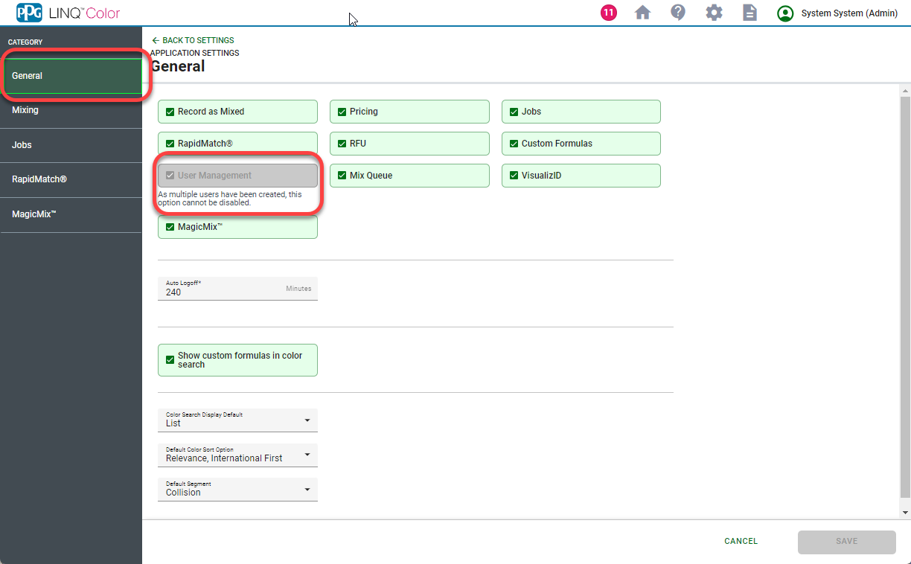

Add a New User
IMPORTANT! None of these actions create or update records in Vantage Point
- Follow the steps to Enable User Management in PPG LINQ.
- On the Home screen, click the Settings tile.

- On the Settings screen, note the User Management tile has been added. Click the User Management tile.
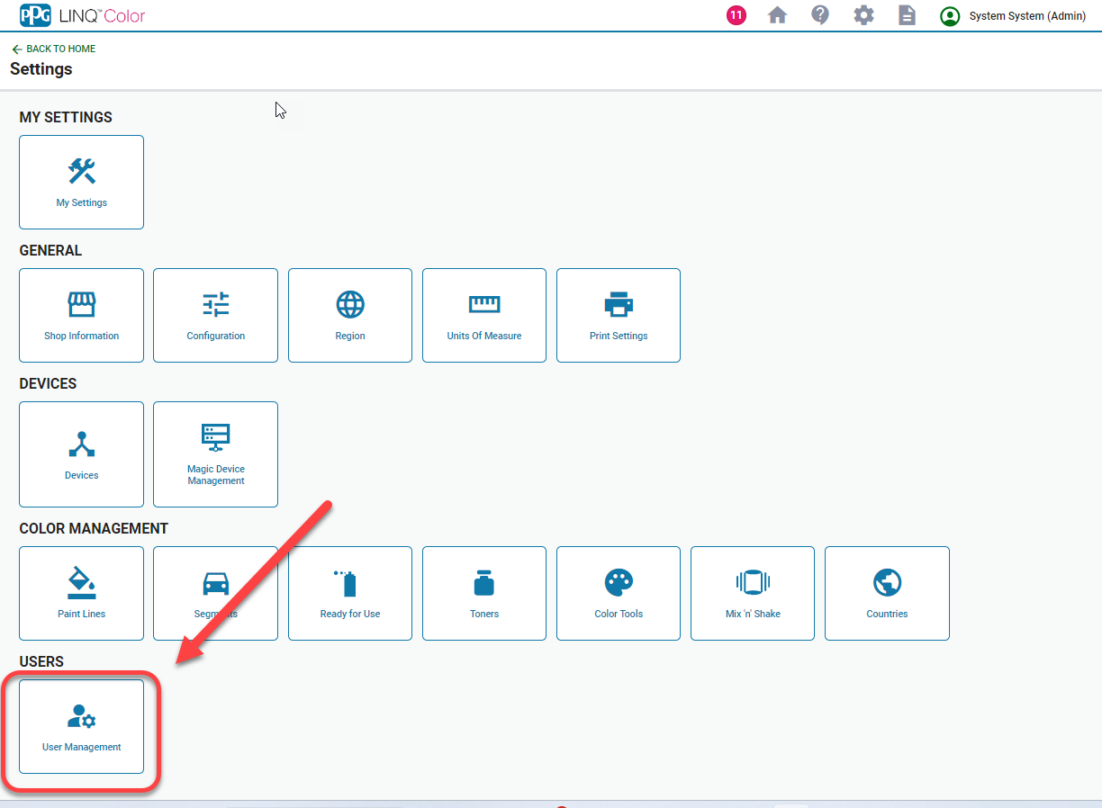
- On the User Management screen, the shop’s users are displayed. Note the ShopAdmin account is listed first.
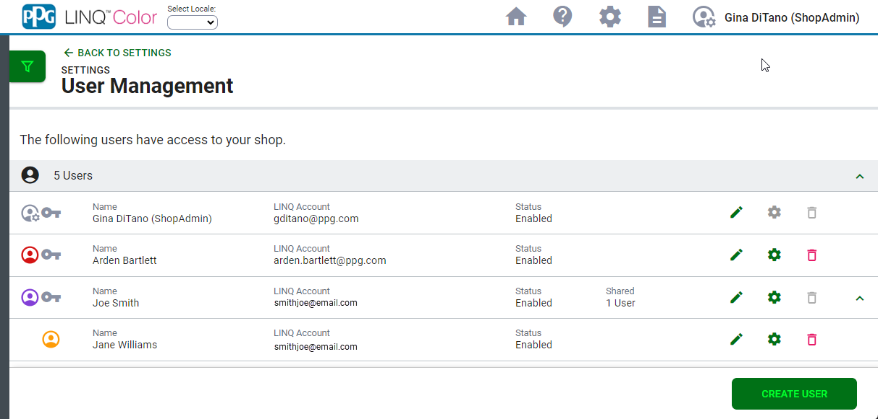

- To create a new user account click the Add User button.
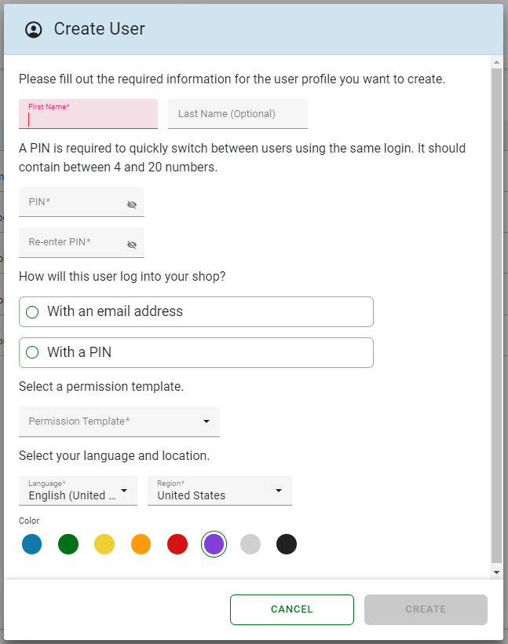
- On the Create User screen, enter a First Name and Last Name.
- Enter and confirm a PIN.
- Choose a permission template for the user (Note: These are the same permission templates as in PaintManager XI).
  - Administrator
  - Manager
  - Painter
  - Mixer / Matcher
  - Prepper
  - Estimator
  - Front Office
- Select a Language and region for the user if an alternate is preferred.
- Select a Color for the User Icon.
- The final step is to choose how the user will log into your shop.
  - With an email address: This will create an individual email-based account. The user will be required to enter an email address and password to log in.
    - Enter an email address for the new account.
    - Click the Use Email button to verify the address; this step activates the Create button.
    - Click the Create button to save the new account. An email will be sent to the address of the new account with instructions to log in.
  - With a PIN: This will associate the user to an existing email-based login account. Users will share the email-based account and each user will use a PIN to switch between their accounts. This enabling quicker access on a shared device.
    - Select the email address with which to associate the user.
    - Click the Create button to save the new account. On the User Management screen, the account will appear under the account with which it was associated.

Add a User to Multiple Shops in PPG LINQ Color
A user who logs in to PPG LINQ Color with an email-based account (known as a “main account”) can be configured to access multiple shops in the system except when their account is shared with sub accounts. If a main account must be enabled at multiple shops but is shared with any sub accounts, move those sub accounts to another main account.
- As the Shop Admin or Admin at one of the multiple shops, follow the steps above to Add a New User and in step 11, select With an email address.
- Enter the same email address as is used at other PPG LINQ Color Shop(s).
- Click the Create button to save the new account. An email will be sent welcoming the user to the shop.

Log In to Another Shop in PPG LINQ Color
- Complete the steps above to Add User to Multiple Shops in PPG LINQ Color.
- Log in to PPG LINQ Color using your email address that is enabled at multiple shops. If the account is correctly enabled at more than one shop, the Where are you working? screen will open.
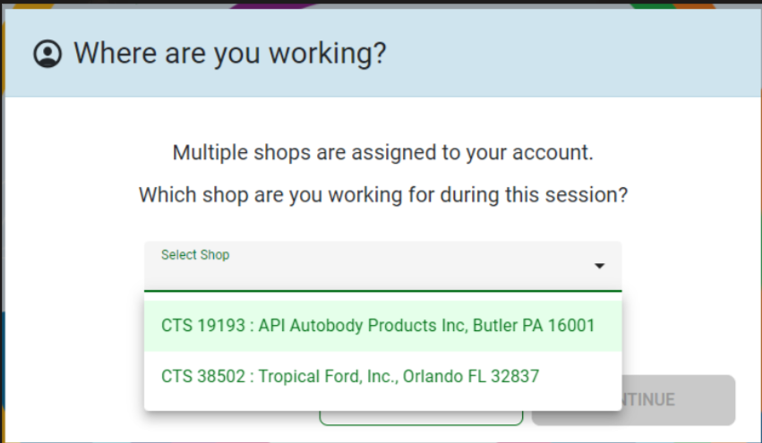
- Select the desired shop and then click the Continue button. The Home screen for the selected shop will display.

Forgot PIN
The process to reset a PIN depends on the type of user.

Main account (uses an email address to login into PPG LINQ Color)
- On the Select User screen, select your name
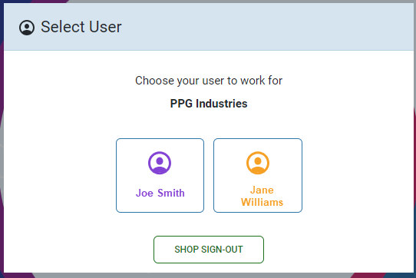

- On the User PIN screen, click Forgot PIN. A new PIN will be sent to your email address. Use the new PIN to log in to PPG LINQ Color.
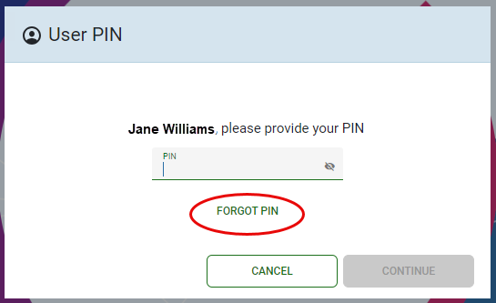

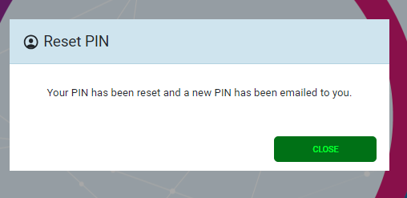

PIN-enabled user (uses a PIN to log in to PPG LINQ Color)
A PIN-enabled user must contact the ShopAdmin to reset their PIN.
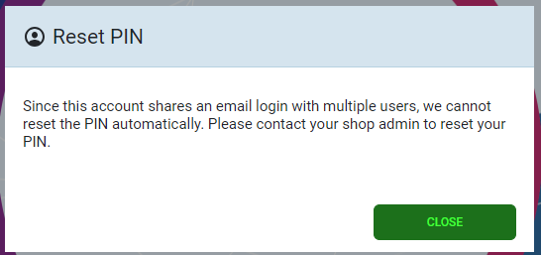

Remove a User
On the User Management screen, click the button for the user to be removed.
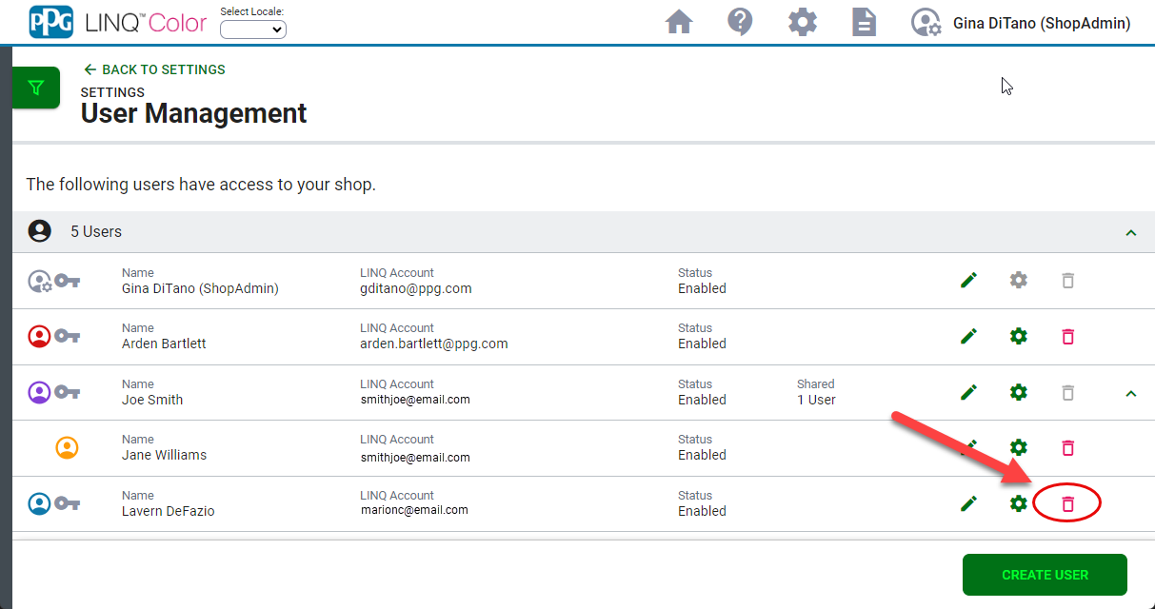

Restore a Removed User
- On the User Management screen, click the Filter button on the left side of the screen.
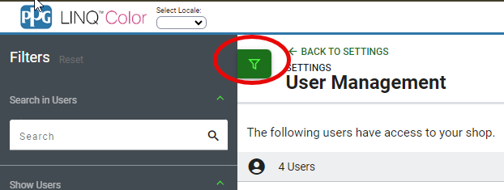

- In the Filters panel, click to place a check in the Removed User option. Users who were previously removed are displayed at the bottom of the list.
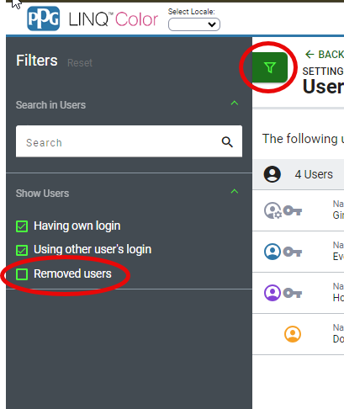
- Click the restore icon of the user to be restored. The Edit and Restore User window opens.
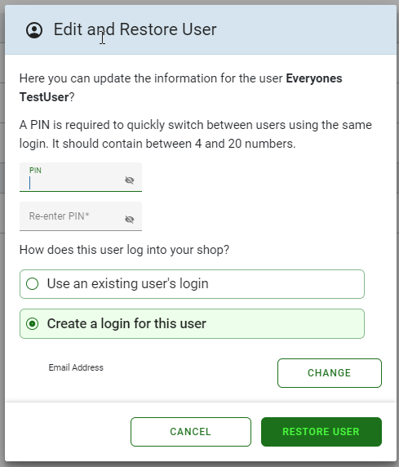

- Complete the required fields and click Restore User. The user is returned to the list of enabled users.
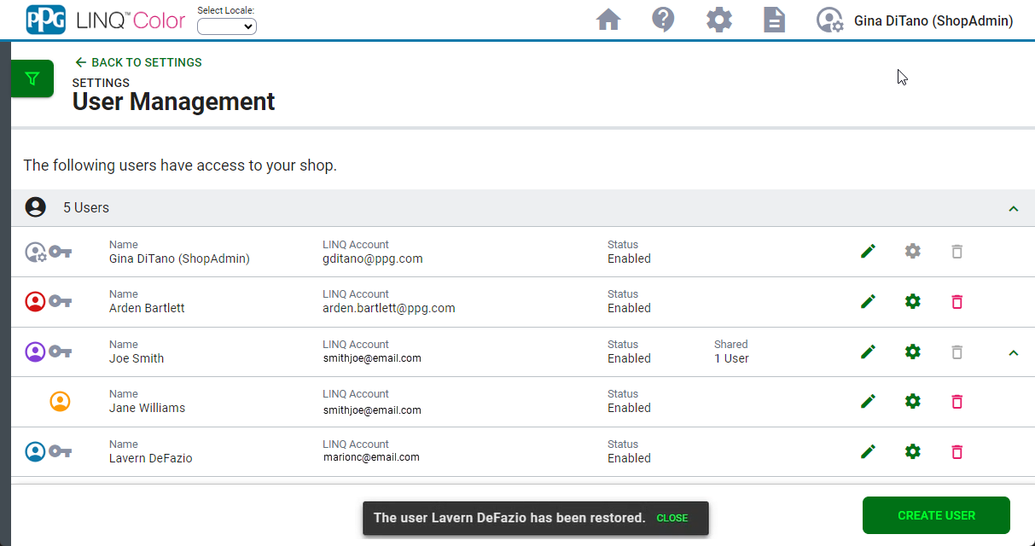

User Icons
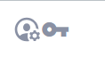 | ShopAdmin: The ShopAdmin account (only one) will have a gear on the user icon.
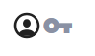 | Key icon: A “main account” for this shop. This is an account which uses an email address and password to log into the shop.
 | PIN enabled user: This account is under/associated to a “main account” and uses a PIN to log in to PPG LINQ. Note: the main account must be logged in to the system before the associated PIN users can switch between accounts.
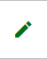 | Edit User: Allows you to edit the user’s settings.
 | Edit Permissions: Allows you to edit the permissions of the user.
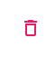 | Remove User: Allows you to remove the user account.  Notes: The ShopAdmin account cannot be removed. A main account (key icon) cannot be removed if it is shared with any sub accounts.

